FOR TOUR U CAN CALL ME AT ANY TIME!!

TOUR A (PICK-UP 08:30AM)
3 PERSONS = USD 55 /PERSON
SAKKARA AREA 4 PERSONS = USD 50 /PERSON
PYRAMIDS OF GIZA 5 – 7 PERSONS = USD 47 /PERSON
PAPYRUS AND PERFUME INSTITUTES 8 AND MORE = USD 45 /PERSON

TOUR B (PICK-UP 08:30AM)
3 PERSONS = USD 55 /PERSON
EGYPTIAN MUSEUM 4 PERSONS = USD 50 /PERSON
PYRAMIDS OF GIZA 5 – 7 PERSONS = USD 47 /PERSON
PAPYRUS AND PERFUME INSTITUTES 8 AND MORE = USD 45 /PERSON

TOUR C (ALEXANDRIA)(PICK-UP 07:00AM)
POMPEY’S PILLAR
CATACOMB OF CHOQAFA 3 PERSONS = USD 60 /PERSON
ROMAN AMPHITHEATRE 4 – 5 PERSONS = USD 52 /PERSON
QAIT BEY’S FORT 6 – 8 PERSONS = USD 44 /PERSON
KING FAROUK’S PALACE 9 AND MORE = USD 38 /PERSON

TOUR D (LIGHT N SOUND)(PICK-UP 05:00PM)
(INCLUDES TICKET+TRANSPORT)(NO MEALS) 4 – 6 PERSONS = USD 22 /PERSON
(IN ENGLISH EVERYNIGHT @ 06:30PM) 7 AND MORE = USD 21 /PERSON
(IN ENGLISH SUNDAY @ 08:30PM)

TOUR E
PHARAONIC VILLAGE 4 – 5 PERSONS = USD 43 /PERSON
KHAN KHALILI BAZARS 6 AND MORE = USD 42 /PERSON

TOUR F (NILE CRUISE)(PICK-UP 06:00PM)
(2 HRS SAILING + TRANSPORT + DINNER EXCEPT BEVERAGE ) 4 PERSONS = USD 23 /PERSON
(AND BELLY DANCER SHOW) 5 – 7 PERSONS = USD 22 /PERSON
8 AND MORE = USD 21 /PERSON
NB:
- TOUR A, B, C AND E AVAILABLE WITH TOURIST GUIDE IN ENGLISH, ENTRANCE FEES AND LUNCH+MINERAL WATER DURING LUNCH.
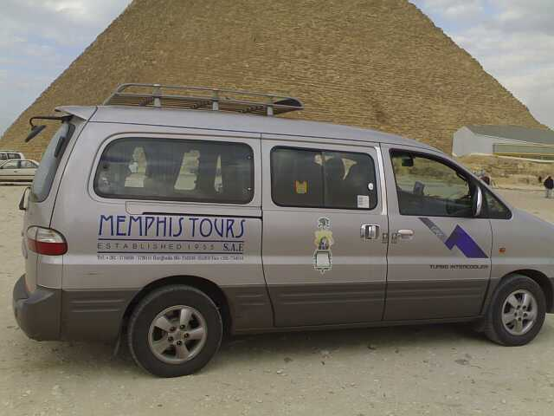
- TRANSPORTATION ARE FULLY WITH AIR-CONDATION.
- LETS ME KNOW EARLIER WHAT TOUR YOU CHOOSE FOR THE
BETTER TOUR.
- WE CAN ARRANGE FOR: - HOTEL DURING YOUR HOLIDAY
- TOUR FOR 01 PERSON, 02 PERSONS
OR THE BIG GROUPS.
- ANOTHER INTERESTING PLACES: SINAI, LUXOR, ASWAN, SAFARI
- PRICE VALID UNTILL 31DIC 2011. VAN FRM 2-7 PERSONS

FOR MORE INFO, CALL OR SMS OR EMAIL ME:
MR AMIR (M) +2 010 675 29 06 EMAIL: amir_cairo64@yahoo.com

